SMART AIR QUALITY MEASUREMENT SYSTEM
INTRODUCTION:
Air pollution is a problem that affects people's health and the environment all over the world. Bad things like smoke and harmful gases come from cars, factories and other places which makes the air dirty and can make people sick. So it is very important to check the air quality to keep people safe and healthy.
This project is about making a system to check the air quality using a computer called ESP32 and special tools called gas sensors like MQ2, MQ3 and MQ135. The MQ2 sensor finds smoke and bad gases.The MQ3 sensor finds alcohol in the air and the MQ135 sensor checks the air quality by finding bad gases and pollutants. The small computer processes the information from the sensors. Then it sends to the internet using Wi-Fi.There is a website that shows what is happening in the environment now so people can check the air quality from anywhere using a phone or computer. The system can also warn people with lights. Sounds when the air is too dirty using things like LEDs and buzzers. This way of checking the air quality is cheap and can be used in many places, inside and outside which helps people know about the environment and stay healthy. The Air Quality Monitoring System is very useful for checking the air quality and the Air Quality Monitoring System helps to keep people safe.

UNDERSTANDING THE PROJECT:
The objective of this project is to monitor the air quality and other important harmful gases in the environment using gas sensors(mq2,mq3,mq135) and show the real time data on a live web dashboard.

HARDWARE USED:
i)ESP32- A low-cost, low-power, microcontroller that is ideal for IoT applications. This includes smart home devices, weather stations, air quality monitors, robotics, Industrial Automation, and Wearable Technology - the ESP32 was developed by Espressif systems, and it is now one of the most widely used microcontrollers around the world.
Main Features-Dual-Core Processor
-Large Memory
-Built-in Bluetooth
-Built-in Wi-Fi
-Low Power Consumption
Communication Protocols -UART
-I2C
-SPI
ii)Sensors
- Gas sensor MQ-2 - This is a commonly-used air quality sensor that detects gases and smoke in order to monitor air quality, find leaks in gas lines, and provide safety to people using it.
- Gas Sensor MQ-3 - This is an alcohol sensor that is also a gas sensor, but it was specifically made to detect alcohol vapors in the air. This is commonly found in breath analyzers, alcohol detection devices and safety monitoring devices.
- Gas Sensor MQ-135 - This is an air quality sensor. It detects harmful gases and other pollutants in the air, and it is one of the most frequently used sensors for projects that monitor air pollution using ESP32 or Arduino.

iii)Alert Device
1) Buzzer - An electronic buzzer produces sound (for instance, to alert you or warn you). Buzzers are used in many applications, including:
- Security system alarms
- Gas leak detectors
- Fire alarms (for smoke)
- Timing devices
- IoT products.
In your air quality monitoring device, a buzzer can alert you when there are excessive levels of harmful gases or smoke in the air.
2) LED - An LED is a type of semiconductor that emits light when electricity is applied to it. LEDs are used for many purposes including: (and the list is endless)
- As indication lights
- As display devices
- As light sources
- As status indicators in technology.
In your air quality monitor, an LED lets you know whether (the) air quality is good or bad.
3) Display - A display module provides you with a means to display information (e.g., readings from your sensors, text messages, and numbers). In projects built using an ESP32 microcontroller (MCU), the display can provide immediate feedback to users by displaying data directly on the module without any need to connect to a computer. One small module frequently used in conjunction with ESP32s, and other MCUs is the SSD1306 OLED Display. An OLED display is different from an LCD; an OLED display uses light-emitting diodes to produce its image (no backlight).

HARDWARE BLOCK DIAGRAM:
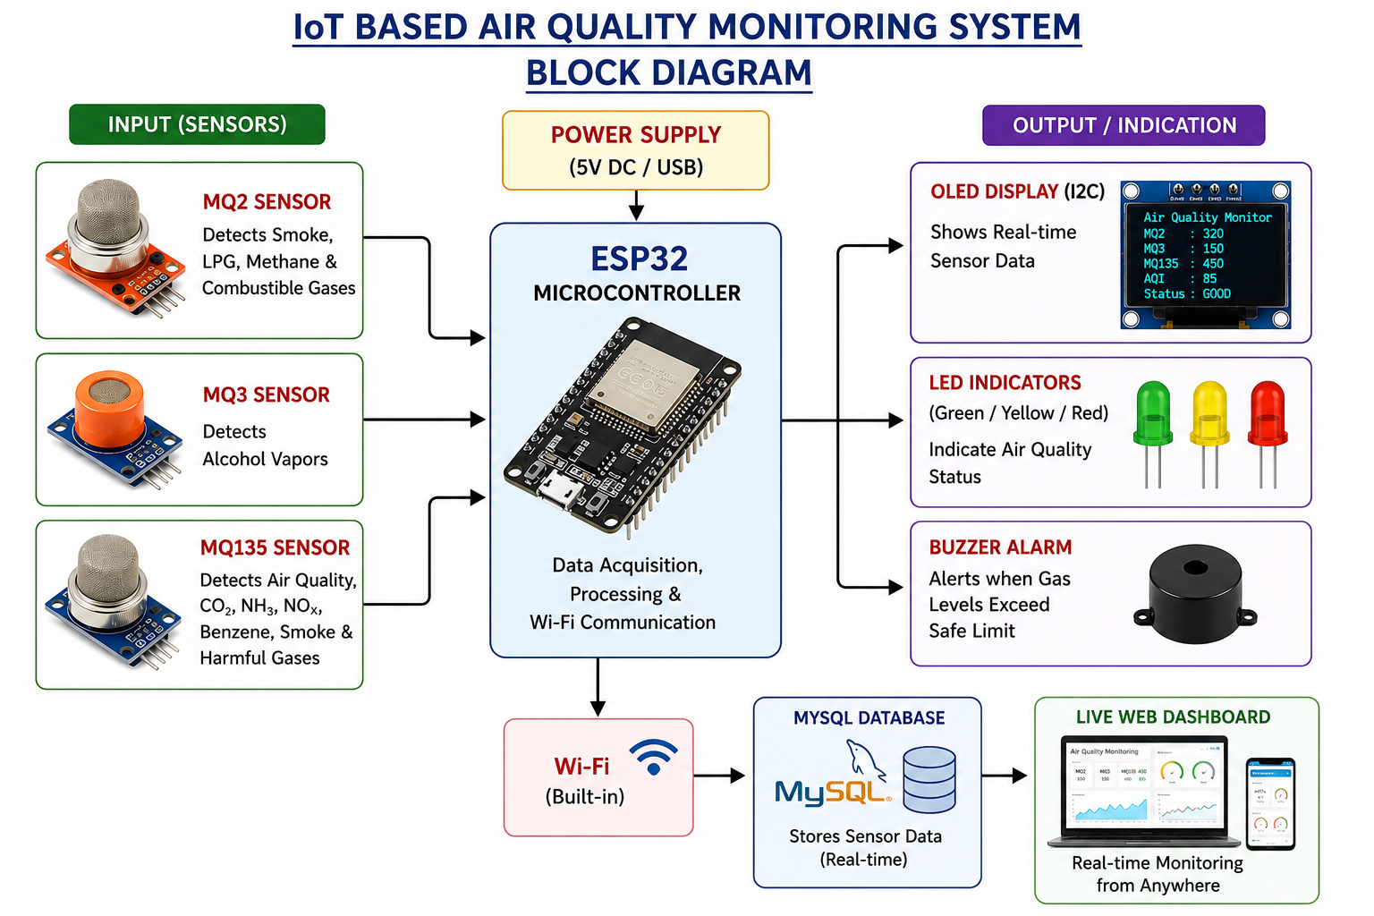
SOFTWARE BLOCK DIAGRAM:

.
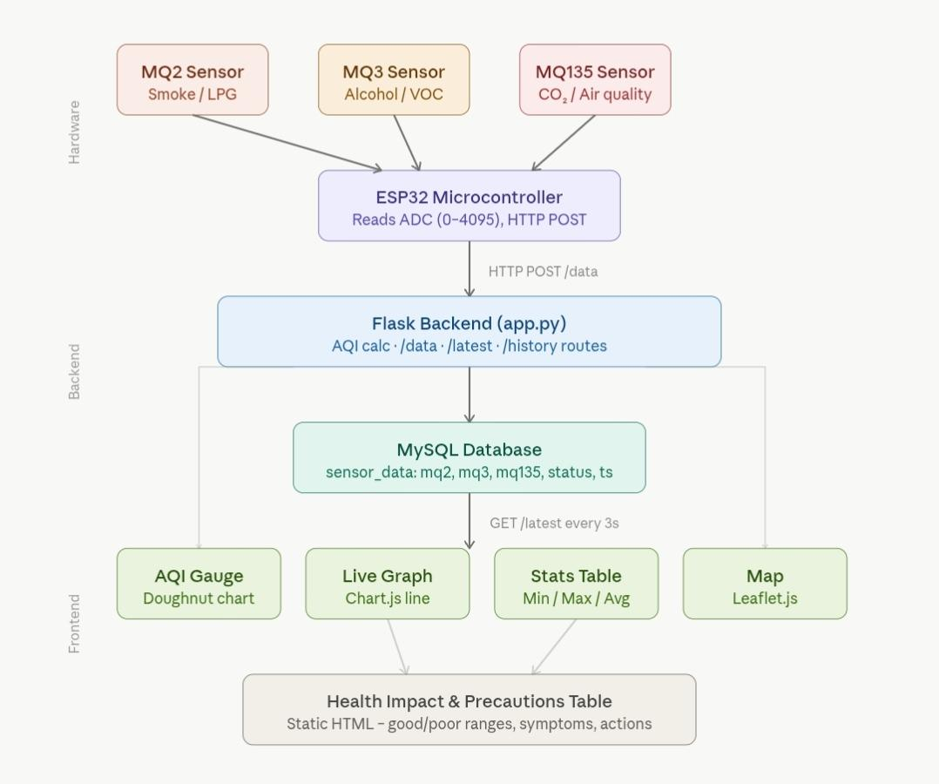

SOFTWARE INSTALLATION

- INSTALL VS CODE,
- MYSQL,
- ARDUINO IDE

LIBRARIES REQUIRED:

IN VS CODE:
- Pip install flask
- Pip install flask-cors
- pip install mysql-connector-python
- pip install pandas

IN ARDUINO IDE:
- WiFi.h
- HTTPClient.h
- Wire.h
- Adafruit_GFX.h
- Adafruit_SSD1306

STEPS TO BUILD THE SOFTWARE:

- Creating database
- Create a database pollution_db to store all the readings .
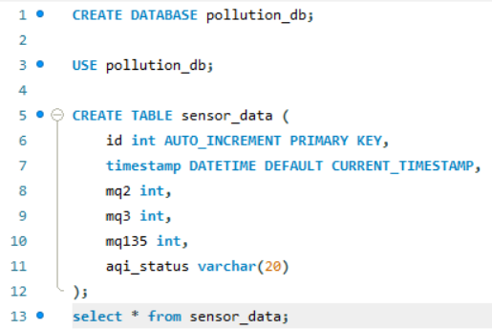
- Create a table sensor_data to store every reading that is received from the sensors.
- The columns are -

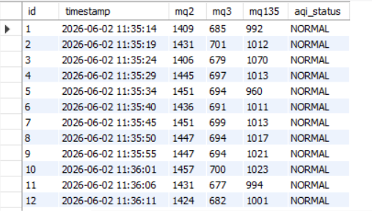

- Creating the folder:

Pollution project
├── app.py
├── templates/
│ ── index.html
│
├── static/
│ ── style.css
│ ── script.js
│
└── database.sql

- App.py:

- Here the language used is python and the server is flask.
- Libraries such as Flask,Flask-CORS,MySQLConnector,and Pandas are used to import web services, connecting with the database and handling operations.
- The major routes in the backend:

Route | Method | Purpose
/data | POST | Reading MQ2,MQ3,MQ135 from the hardware, calculates AQI and stores it to the database.
/latest | GET | Returns the latest reading
/history | GET | Returns the latest 50 readings for monitoring
/dashboard | GET | Opens HTML dashboard
/ | GET | Opens homepage

Here there are the important jobs:

- To create a website we need flask as flask acts as a between arduino database and website. It transfers data and handles communication. It receives data, processes it, stores it in the database, and provides data to the website.
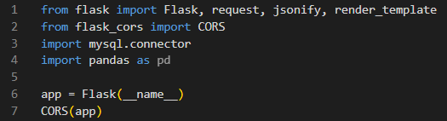

- A connection is established with the MySQL database (pollution_db) by specifying the host, username, password, and database name. This connection is used for storing and retrieving sensor data.
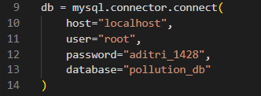

- “@ app.route” is used to create routes.
- “@ app.route(“/”)- sends the html page(home page) to the browser.
- @app.route("/dashboard") - Open dashboard when visited.
- @app.route("/latest")- sends data to website
- @app.route("/history")- returns 50 latest readings
- @app.route("/data")-receives sponsor values from the hardware and then stores the values into the database.

- Db.cursor is used to create the cursor database and to execute a sql query. It also retrieves the latest MQ2, MQ3, MQ135, and AQI status record from the sensor_data table. It allows Flask to communicate with the MySQL database for storing and retrieving the data of the sensor.
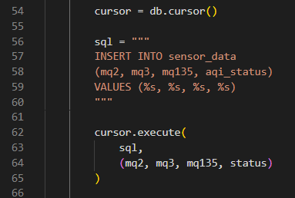

- AQI formula is
avg=(MQ2+MQ3+MQ135)/3
aqi= int ((avg/4095.0)*500)
The AQI is calculated on basis of a given parameter -

AQI | Status
0-50 | Good
51-100 | Satisfactory
101-200 | Moderate
201-300 | Poor
301-400 | Very Poor
400-500 | Severe

- After AQI calculation ,the data is stored into the sensor_data table of the MySQL database pollution_db.

- A JSON response is created and returned to confirm successful data storage.

- If any error occurs an exception is thrown using try-except block to detect the errors in the database or while running the webpage.

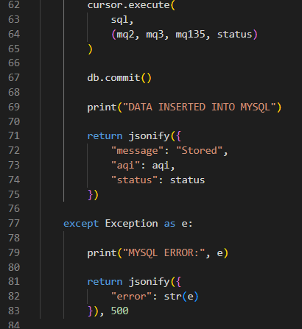

- The /latest route retrieves the recent sensor record from the database and sends the latest MQ2, MQ3, MQ135, AQI, and status values to the dashboard for real-time monitoring.
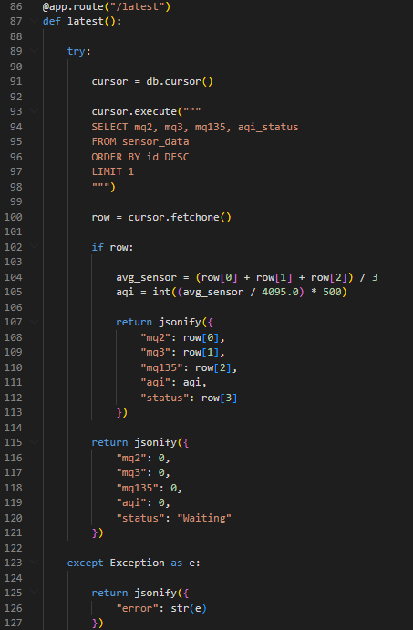

- The /history route retrieves the latest 50 sensor records from the database and provides historical air quality data for analysis and visualization.
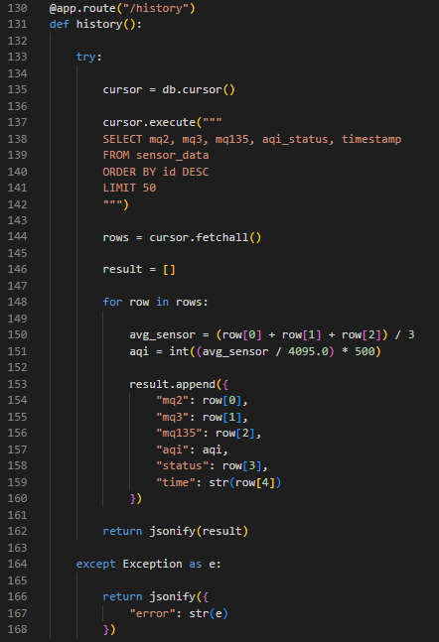

- Finally, the processed sensor data is stored in the database, while the /latest and /history routes retrieve current and historical records in JSON format for real-time dashboard visualization and monitoring.

3. Creating a website:

INDEX.HTML-
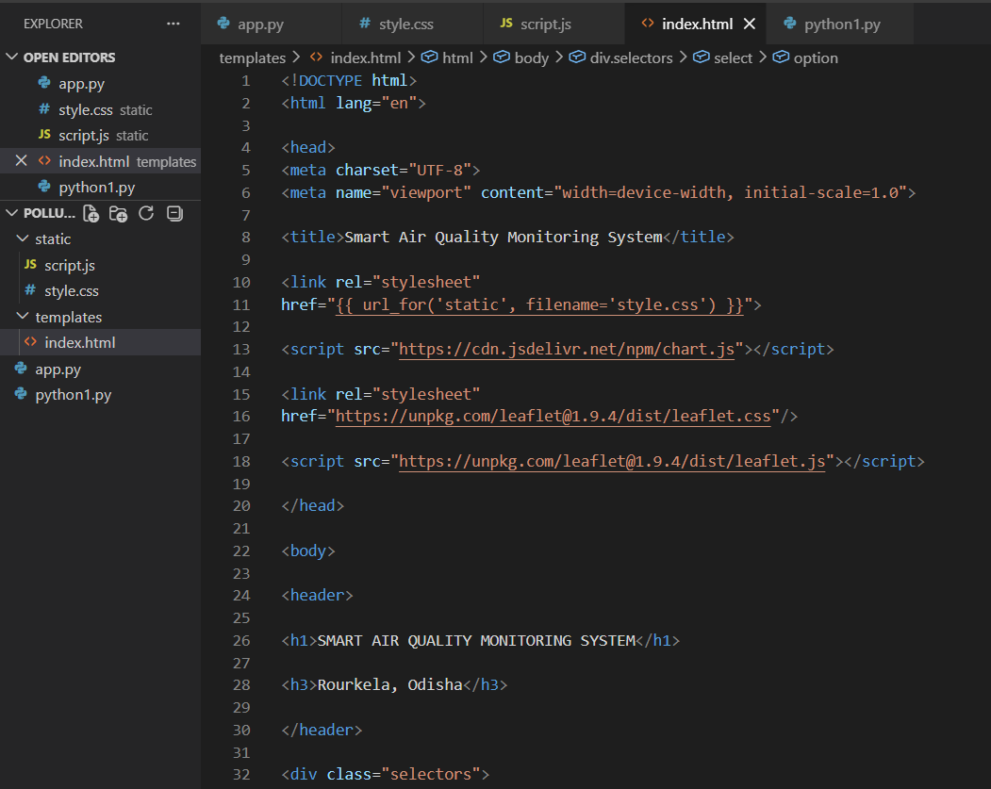

- The index.html is an overall structure of the dashboard .

- The index.html is initialised by <!DOCTYPE html>.
- Some external libraries are linked by :
  - Style.css- Styling the dashboard
  - Chart.js- AQI gauge and live graph
  - Leaflet.js,and OpenStreetMap- map visualization

- A header section contains the project title ”SMART AIR QUALITY MONITORING SYSTEM”

- A set of sections are done where dropdown menu are added for the user to select state,city,station
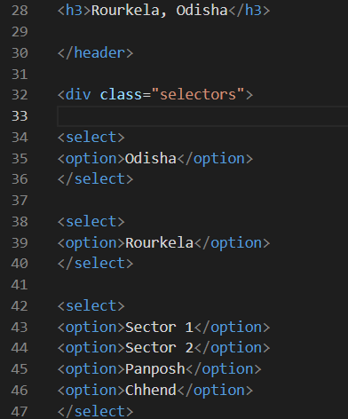
.
- A geographic location on an interactive map is created to show the location of the air monitoring station.

- An Air Quality Index (AQI) display is created and includes many different formats of the air quality index. The following formats are used for this display:
- A Canvas for displaying the air quality index gauge chart
- A numerical value representing the AQI
- An air quality indication

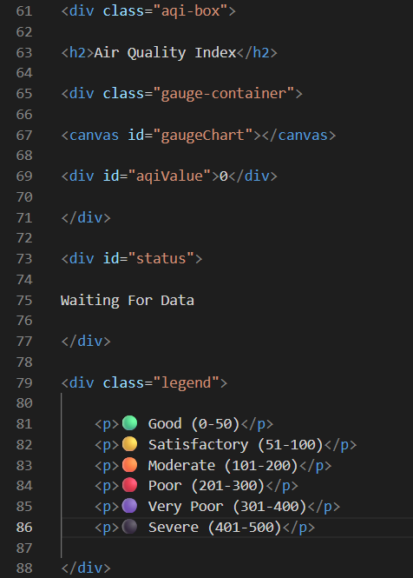
- The website has a graph that uses a Canvas for displaying real-time data from each individual sensor using the Ajax technique.

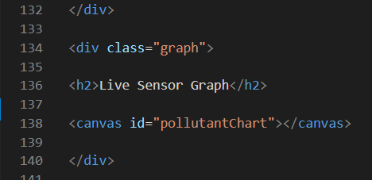

- A statistical display that shows the minimum, maximum, and average values from each individual sensor.
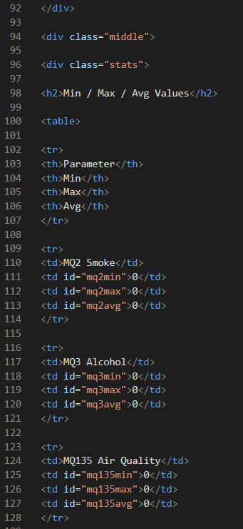

- the Javascript file script.js is linked to the web page so that when data is fetched through Ajax requests, the charts automatically update, the map will initialize correctly, and real-time data from sensors will display on the dashboard.
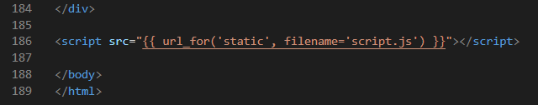

Style.css

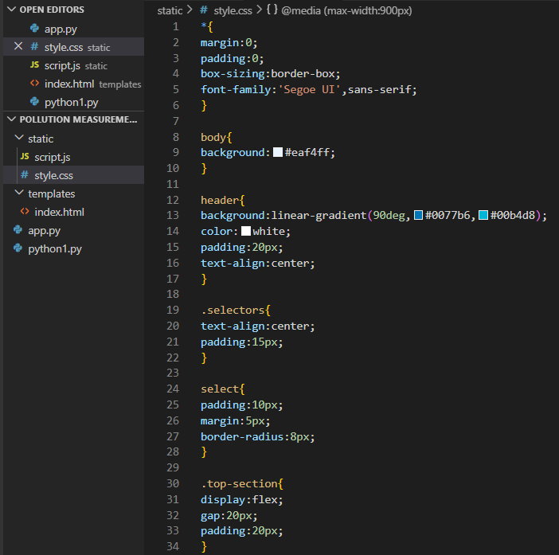
- The style.css file is used to design the dashboard and improve its visual appearance.
- A common style is applied throughout the webpage by removing default margins and padding, setting box sizing, and defining the font family.
- The header section is styled using a blue gradient background, white text, and center alignment to highlight the project title.
- Dropdown menus are styled with padding and rounded corners to provide a user-friendly interface for location selection.
- Flexbox layout is used to arrange the map, AQI section, statistics table, and live graph in an organized manner.
- Dashboard components such as the map, AQI display, graph, statistics table, and health advisory section are designed as cards with white backgrounds, rounded corners, and shadow effects.
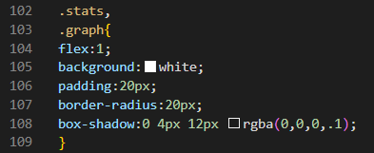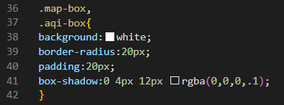
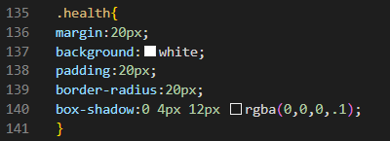
- The AQI value is displayed prominently using larger font size and bold styling, while the AQI status is shown through a colored badge.
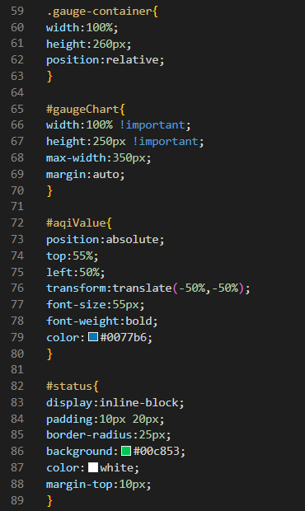
- Tables are styled with colored headers, proper spacing, and alternating row colors to improve readability.
- Responsive design is implemented using media queries so that the dashboard adapts properly to different screen sizes.

Script.js

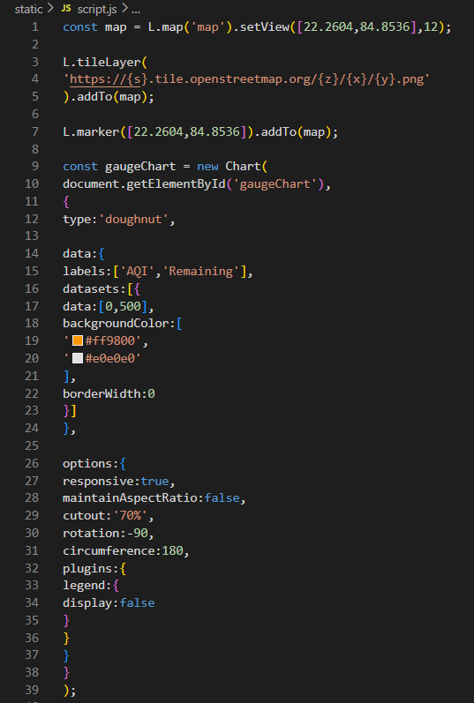
- The script starts by setting up a Leaflet.js map. It is centered at Rourkela coordinates, which're 22.2604°N and 84.8536°E.The map uses OpenStreetMap tiles. A marker is added to show where the monitoring station is located.
- A chart is made using Chart.js to display the Air Quality Index (AQI). This chart is a half-doughnut shape. It shows the AQI value, which ranges from 0 to 500.
- A live graph is created using Chart.js line charts. There are datasets for each sensor:
  - * MQ2, which is a Smoke Sensor
  - * MQ3, which is an Alcohol Sensor
  - * MQ135, which is an Air Quality Sensor
- Three arrays are created to store data from the sensors:
  - mq2 History
  - mq3 History
  - mq135 History
These arrays store sensor readings from the session. They are used later for calculations.

- We create live sensor graphs that are based on Chart.js line charts. For each type of sensor: MQ2 (smoke), MQ3 (alcohol), and MQ135 (air quality), we also create separate datasets.
- During each session, we will store what we have read from these sensors into 3 separate JavaScript arrays (mq2History, mq3History, and mq135History), and then use the information in those arrays to do our statistical calculations.
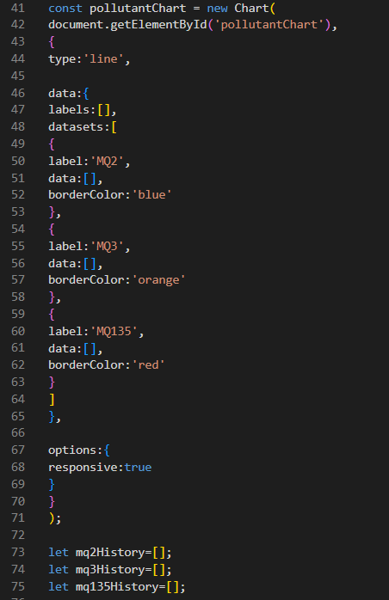

- A function called getAvg() is made to find the average of sensor readings that are stored in history arrays.
- The main function, updateDashboard() gets the sensor data from a Flask backend. This is done by using the API endpoint.
- When the data is received from the server the script pulls out these values:
  - MQ2 value
  - MQ3 value
  - MQ135 value
  - AQI value
  - AQI status

- The getAvg() function helps to calculate the value of MQ2, MQ3 and MQ135 sensor readings. The updateDashboard() function uses getAvg() to show the average sensor readings, on the dashboard.MQ2, MQ3 and MQ135 values are used to calculate AQI value.The AQI value then determines the AQI status.
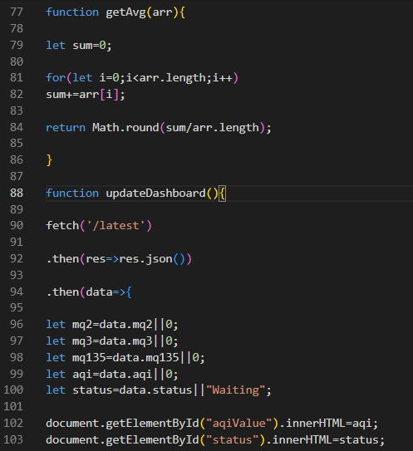
- At the dashboard, both the AQI's current value and current status will appear. By adjusting the dataset that represents the AQI on a gauge chart, the gauge chart can be dynamically updated and re-displayed.
- When a new sensor value is received it will be represented on the live graph with its respective timestamp. If there are more than 15 records on the live graph, older values will be automatically removed from the graph so that a "rolling" time window is maintained for the live graph.
- Each new sensor value will be entered into its respective history array. As new sensor values are added to their respective history array, the script will continuously recalculate and update:
  - The minimum value
  - The maximum value
  - The average value
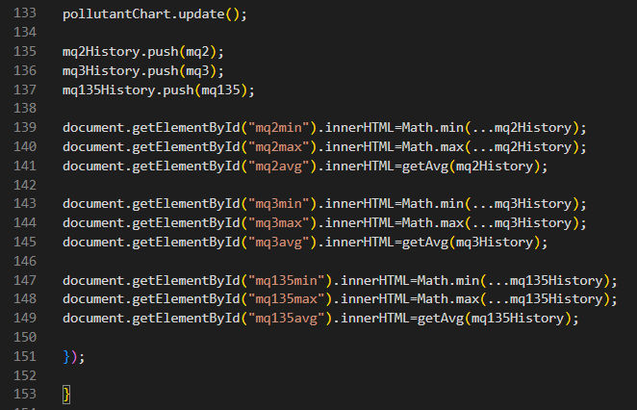
- The first time that the dashboard update function is called occurs when a page is first loaded (it retrieves the most current information).
- Each time that the page is opened after this initial call to updateDashboard, it will execute every 3 seconds via the setInterval() function which allows real-time monitoring and displaying of air quality data.
